A DTW and Fourier Descriptor based approach for Indian Sign Language Recognition

Under the guidance of:
Dr Prabjot sir

Prepared by:
Rajat dua preet pal. Ananya sharma
Computer Science & Engineering

CANDITATE’S DECLERATION

We hereby declare that I own the full responsibility for the information, results etc. provided in this PROJECT titled “A DTW and Fourier Descriptor based approach for Indian Sign Language Recognition" submitted to RWX Technology for the award of certificate of Certificate of Summer Internship done during June-July, 2016. We have taken care in all respect to honour the intellectual property right and have acknowledged the contribution of others for using them in academic purpose and further declare that in case of any violation of intellectual property right or copyright we shall be fully responsible for the same. Our supervisor should not be held responsible for full or partial violation of copyright or intellectual property right.
NAME :
- Rajat dua
- Preet pal
- Ananya sharma

Contents

Candidates declaration-----------------------------------------2

Abstract----------------------------------------------------------- 4

Introduction------------------------------------------------------5

Motivation--------------------------------------------------5

Problem statement----------------------------------------6

Applications------------------------------------------------6

Flowchart-----------------------------------------------------------8

Algorithm-----------------------------------------------------------9

DTW------------------------------------------------------------10-12

Contour------------------------------------------------------------13

Fast Fourier transformation-------------------------------14-15

Fourier descriptor--------------------------------------------16-18

Conclusion and future scope----------------------------------- 19

Reference-----------------------------------------------------------20

ABSTRACT
Indian Sign Language (ISL) Interpretation system is a good way to help the Indian hearing impaired people to interact with normal people with the help of computer.

An ISL vocabulary show that the hand plays a significant role in ISL. ISL includes static and dynamic hand gesture recognition.

Humans with hearing disabilities are highly dependent on non-verbal forms of communication involving hand gestures. A gesture recognition system capable of transforming gestures to other forms of communication can bring about a significant improvement in the quality of life of such human beings.
A novel approach making use of Fourier Descriptors for shape extraction followed by Dynamic Time Warping for sequence matching in order to recognize gestures representing English alphabets present in the Indian Sign Language (ISL).

INTRODUCTION

Motivation
Imagine a world without sound and the frustration of trying to express what you feel or need to others. In India, there are approximately 78 million hearing-impaired individuals. Cochlear implants have brought hearing to some, while others in the deaf culture opt to keep sign language as their method of communication.
Many deaf people feel one of their biggest difficulties is the hearing culture that treats them as though they are handicapped, people to be pitied or changed. According to the PBS documentary "Sound and Fury," a fairly large percentage of deaf people---especially those deaf from birth---would opt out of the hearing world, no matter what current or future technologies were offered.
Darby J. Leigh, a graduate student who was born deaf, states "losing deafness could be as terrifying a change as waking up with a different gender."

Childhood Struggles
In many ways, deafness is hardest on children. Language is learned from hearing it spoken by parents and peers. Deaf children struggle with communicating far longer than hearing children, as they must be taught sign language and the ability to read lips. They often can feel secluded and lost. Most small children go through stranger anxiety phases. Imagine the fear of a deaf toddler who, while riding in a stroller, is approached by an admiring stranger. Though the stranger might have friendly intentions, it is difficult for a deaf child to fully understand this by sight alone.

Problem Statement
“To recognize hang gesture of English alphabet use in Indian sign language using DTW and FOURIER DESCRIPTOR approach”
Applications
Some application of Indian sign language recognition system are given below :
- It help deaf peoples to communicate with normal peoples.
- Help to create dictionary of sign language.

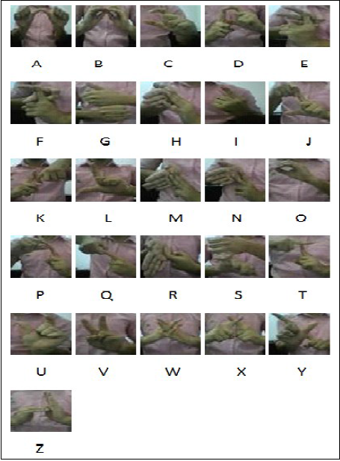
Fig : Gestures of all English alphabets of Indian sign language
Flow Chart
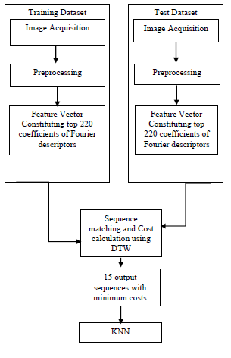
Fig : Block diagram of proposed approach for ISL gesture recognition
Algorithm
- Collect data set of all alpha numeric gesture of Indian sign language.
- Remove background and convert images into binary images
- Separate the data into two sets(80% training & 20% testing)
- Extract outer Contour of binary images
- Extract Centroid of Contour
- Calculate distance matrix (distance of all points of contour to centroid).
- Apply Fast Fourier Transformation
- Apply Fourier Descriptor
- Feature vector consisting of top 220 coefficient of Fourier descriptor
- Do above for all testing and training data
- Now combine feature vector of all alphabet to a single matrix(one matrix for training and one for testing)
- Calculate cost of one row of Testing matrix to each rows of training matrix and store them into row vector
- Create a index matrix and sort both (index and cost matrix)
- Take minimum 15 cost and there corresponding indexes
- Apply KNN

DTW (Dynamic Time Wrapping)
In particular the problem of detecting different patterns includes many importance of pattern detection in time series.
Consider two sequences A and B, composed respectively of n and m features in our sequences we are considering slopes of the patterns.
A = a_{1,} a2, a3, a4, a5…a_{n}
B = b₁, b₂, b₃, b₄, b₅…b_{n}
Each feature vector is d dimensional and thus can be represented as a point in a d-dimensional space. For example in pattern detection we use the raw(x,y) coordinates of the moving green pen cap that would make us sequences of 2 dimensional vectors. It’s also worth nothing that the sequences A and B can be of different lengths depending on the frames that we take.
TIME WARPING
DTW works by warping the time axis iteratively until an optimal match between the two sequences is found.
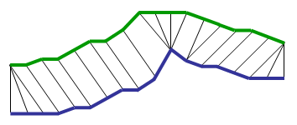

In the figure above, which is an example of two sequences of data points with only 1 dimension, the time axis is warped so that each data point in the green sequence is optimally aligned to a point in the blue sequence.
WARPING PATH
First we need to construct a distance matrix n x m. In this distance matrix each cell represents the distance between the j-th element of A and i-th element of B.
Dist_matrix (i, j) = |A_{i} - B_{j}|;
After calculating the distance matrix the second step what we need to do is to calculate cost matrix, based on distance matrix.
Finding the best alignment between two sequences can be seen as finding the shortest path to go from the bottom right cell (n x m) to the top left right (1,1) cell of the cost matrix. Assuming local constraints like below, it allow u`1s to define the cell (i, j ) recursively :
V = [cost_matrix (i-1, j), cost_matrix(i-1, j-1), cost_matrix(i, j-1)];
cost_matrix(i, j) = dist_matrix(i, j) + MIN(V);
Finding the alignment between two sequences can be seen as finding the shortest path to go from the bottom right (n x m) cell to the top left (1, 1) cell of that cost_matrix. The length of a path is simply the sum of all the cells that were visited along that path. The further way the optimal path wanders from the diagonal, the more the two sequences need to be warped to match together. The brute force approach to finding the shortest path would be to try each path one by one and finally select the shortest one. However this would result in explosion of paths to explore.
CONSTRAINTS FOR WARPING PATH
DTW can impose several kinds of reasonable constraints, to limit the number of paths to explore.
MONOTONICITY: The alignment path doesn’t go back in time index. This guarantees that features are not repeated in the alignment.

CONTINUITY: The alignment doesn’t jump in time index. This guarantees that important features are not omitted.
BOUNDARY: The alignment starts at the bottom right and ends at the top left. This guarantees that the sequences are not considered only partially.
WARPING WINDOW: A good alignment path is unlikely to wander too far from the diagonal. This guarantees that the alignment doesn’t skip different features or get stuck at similar features.
SHAPE: Aligned paths shouldn’t be too steep or too shallow. This prevents short aligned with long ones.

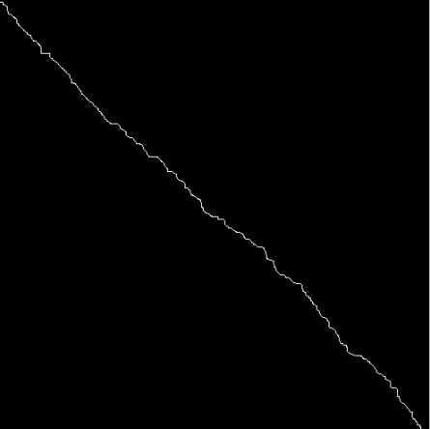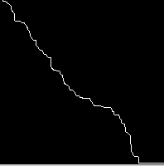
Fig : The minimum warping path for two sequences

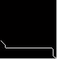
Fig : Example of Incorrect warping path

Contour
The contour or the external boundary points of the image are extracted and the coordinates of these boundary points are stored for further processing. Edge detection techniques were used for extracting the external Contours of the image. The process of contour extraction for image denoting alphabet S has been shown in below Fig.


(a) Binary image of English alphabet A.
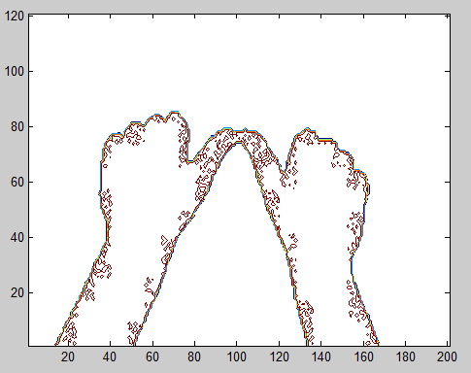 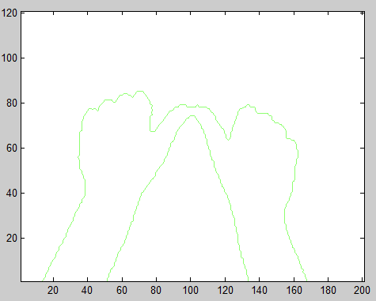(b) Contour extraction of binary image (c) Outer boundary of contour

Fast Fourier Transformation (FFT)
A fast Fourier transform (FFT) algorithm computes the discrete Fourier transform (DFT) of a sequence, or its inverse. Fourier analysis converts a signal from its original domain (often time or space) to a representation in the frequency domain and vice versa. An FFT rapidly computes such transformations by factorizing the DFT matrix into a product of sparse (mostly zero) factors. As a result, it manages to reduce the complexity of computing the DFT from O(n²), which arises if one simply applies the definition of DFT, to O(nlogn), where n is the data size.
Fast Fourier transforms are widely used for many applications in engineering, science, and mathematics. The basic ideas were popularized in 1965, but some algorithms had been derived as early as 1805. In 1994 Gilbert Strang described the FFT as "the most important numerical algorithm of our lifetime" and it was included in Top 10 Algorithms of 20th Century by the IEEE journal Computing in Science & Engineering.

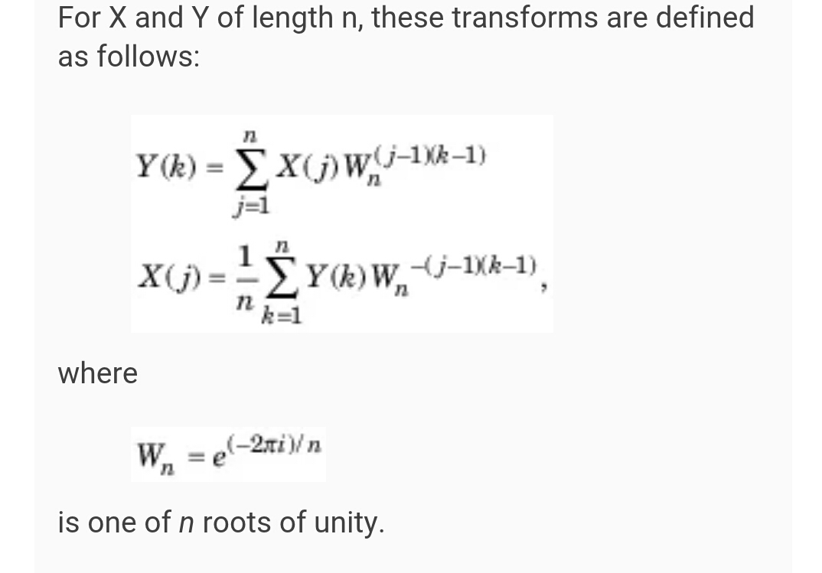

Fourier Descriptor
Let 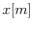 and 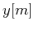 be the coordinates of the m^{th} pixel on the boundary of a given
2D shape containing pixels, a complex number can be formed
as 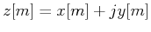, and the Fourier Descriptor (FD) of this shape is defined as the DFT of 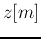:
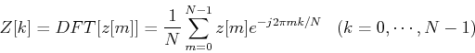

FD can be used as a representation of 2D closed shapes independent of its location, scaling, rotation and starting point. For example, we could use 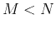 FDs corresponding to the low frequency components of the boundary to represent the 2D shape. The reconstructed shape based on these FDs approximate the shape without the details (corresponding to the high frequency components susceptible to noise). However, note that since the Fourier transform is a complex transform, the frequency spectrum has negative frequencies as well as positive frequencies, with

the DC component in the middle. Therefore the inverse transform with components needs to contain both positive and negative terms:
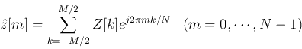

Fourier descriptor has the following properties:
- Translation
If the 2D shape is translated by a distance 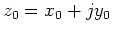:
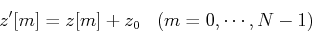
its FD becomes
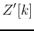 |  | 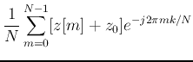
 |  | 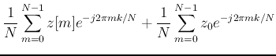
 |  | 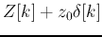
i.e., the translation only affects the DC component 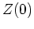 of the FD.

- Scaling
If the 2D shape is scaled (with respect to origin) by a factor :
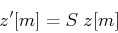
its FD is scaled by the same factor:
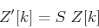
- Rotation
If the 2D shape is rotated about the origin by an angle :
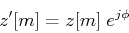
its FD is multiplied by the same factor
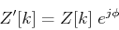
- Starting Point
If the starting point on the boundary is shifted from 0 to :
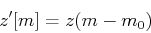
by time shifting theorem, its FD becomes
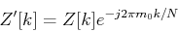

Conclusion and Future Scope
A technique to classify gestures representing English alphabets in the ISL from static images has been presented in the paper. Fourier descriptors were used as feature vectors and Dynamic Time Warping with KNN was used for recognizing these gestures.
The results of the proposed algorithm were compared with other classification techniques as well as with the existing approaches used for recognizing gestures in the ISL from static images.
The main focus in the future shall be on the application of the proposed algorithm on real time videos for recognizing dynamic gestures. Future emphasis will be laid on reducing the time complexity of the algorithm so that the approach can be suitable for real time applications. The algorithm will also be tested on larger class of gestures including numerals and other standard gestures.

